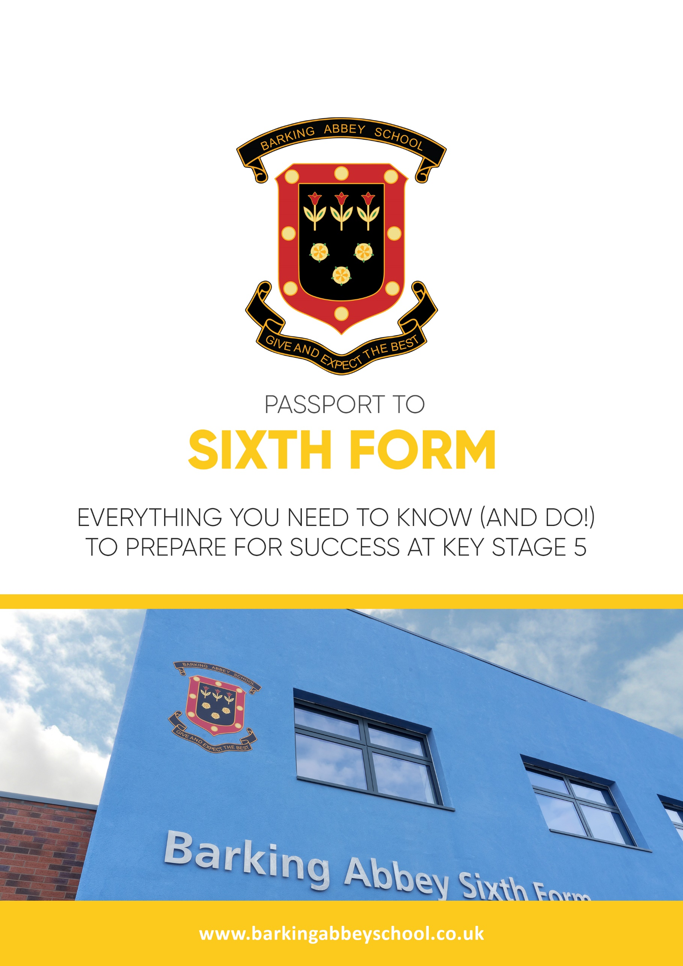

PASSPORT TO

SIXTH FORM

Everything you need to know (and do!)
to prepare for success at Key Stage 5
Contents

Introduction and Activity one:
Get your W.I.G. straight

Activity Two:
Making the right choice: A-levels, BTEC or both?

Activity Three:
Making the right choice – which subjects should I choose?

Activity Four:
Making the most of the Year 11 Summer Holidays!

Activity Five:
- Getting organised for Sixth Form
- Surviving the Start of Year 12

Introduction

Hello Y11, and welcome to your Passport to Sixth Form! The next two years will fly by, and it is so important that you make the most of them. This means studying the right combination of subjects for you, and for you only. Focus on what you want to do, not on what others believe you should do. The information and activities in this Passport should provide you with everything you need to know in order to embark on a successful KS5 journey.

- Get your W.I.G straight

So, let’s begin. First of all, what is you W.I.G? (Your Wildly Important Goal – consider where you hope your Sixth Form studies will lead you – if the answer is ‘free periods and socialising’ you might want to think again!). Your W.I.G should be the reason you have decided to further your studies at a school, rather than joining a college or completing an apprenticeship.



My W.I.G is…………………….

Before you move on to the next task, reflect:

- Do you know what you will need to do to ensure that you achieve your
W.I.G? (work experience, further reading, MOOCs, choice of subjects etc.)
2. Making the right choice: A-levels, BTEC or both?

Employers, apprenticeship schemes and universities all view A-levels and BTECs equally. So, the first tip, is to not worry how your choice of qualifications will be viewed; a good grade at KS5 is a good grade, no matter how you achieved it. If you need further proof or reassurance look at the qualification conversion table below

UCAS Tariff Points | Triple BTE | Double BTE | BTEC | A Level
168 | D*D*D*
160 | D*D*D
152 | D*DD
128 | DDD
112 | DMM | D*D*
104 |  | D*D
96 | MMM | DD
80 | MMP | DM
64 | MPP | MM
56 |  |  | Distinction* | A*
48 | PPP | MP | Distinction | A
40 |  |  |  | B
32 |  | PP | Merit | C
24 |  |  |  | D
16 |  |  | Pass | E
*most universities have an average offer of 120 tariff points.
More information on BTECs:
It is worth reading the information below to ensure that you can make an informed choice on Enrolment Day (even if you think you are set on A-levels only)

BTECs are designed for young people interested in a particular sector or
industry but who are not yet sure what job they would like to do. They combine practical learning with subject and theory content.

If a subject is coded S it means it is available as a Single Award BTEC and you would choose this in combination with two other A-LEVELs or Double BTECs.

If a subject is coded D it means it is available as a Double Award BTEC and you would choose this in combination with one other A-LEVEL or Single BTEC.
If a subject is coded T it means it is available as a Triple Award BTEC and you would choose this on its own and be a Full Time student in this subject.

At Barking Abbey we offer the following BTECs:

- BTEC IT (S) - popular with students who wish to pursue a career in Software Engineering, IT and Computing

.
- BTEC Business (S or D or T) – popular with students that wish to leave school and move on to a degree apprenticeship or to begin employment straight away.

- BTEC Performing Arts (S or D) –popular with students who wish to gain a basic introduction to the performing arts sector alongside other fields of study.

- BTEC Sport (S or D or T) –popular with students who have a keen interest in sport and wish to work within the sports sector, gaining a broad understand of the different roles they could work within

- Making the right choice – which subjects should I choose?

Most students will study three subjects. Answer the following questions to ensure that you are making a wise choice:

Current Strengths

At GCSE, in which subjects do you currently achieve your highest grades?

Look at your list again, which of those subjects have you enjoyed at GCSE?

Now look a final time, which of these subjects come quite ‘naturally’ to you?
(This question is about ease rather than enjoyment)

Preferred Learning Style

- Do you enjoy writing essays? Y/N
- Do you prefer subjects where the answer is definite? Y/N
- Do you prefer subjects where the answer is up for debate? Y/N
- Do you need the security of coursework? Y/N
- For homework, would you rather be a) completing wider reading or
b) completing practice questions? A/B

Trying something new?

Courses such as Economics, Psychology and Sociology are always incredibly popular because you get to learn something brand new. Whilst this a commendable reason to choose these subjects, remember that you will begin Y12 with no prior knowledge.

Discuss: what could be the advantages and disadvantages of this?

Advantages:

Disadvantages:

For most students, it really doesn’t matter which combination of subjects you choose, as long as you are prepared to work hard to secure good grades. Very few university courses specify which A-level/BTECs you must take. The only courses with specific subject requirements are:

- Veterinary Science
- Medicine
- Physiotherapy

(N.B. For almost all degrees and future careers you will need a GCSE Grade 5 in both English Language and Maths, so be prepared to re-sit these in Y12 if you miss out.)

Most other degrees have what we would call ‘logical requirements’ (for example you wouldn’t be able to do a Maths degree if you had not studied it at A-level). However, it is always worth double checking…

If you have a career in mind, research it, and write your findings in the space below:

To become a ………………………………………………………………………………………………………………………

To do a degree in ………………………………………………………………………………………………………………..

I will need to have studied…………………………………………………………………………………………………….

If you still have no idea what your future holds, that is absolutely fine! Do not worry; by the end of Y12 you will no doubt have settled on something – even knowing you want to get an apprenticeship rather than go to university is a good place to start.*

Year 12 and Year 13 students always worry about what the future will hold, or what job they will be able to get. There are two important and reassuring things you need to know:

1)There are thousands of different jobs out there, most you have not even heard of yet! So, do not panic, and be open minded when you eventually start the search.

2)Universities use ‘students employed after X months’ as one of their biggest marketing tools
– during your final year of university, they will organise recruitment fairs based on your
degree- it is in their interest to help you to get a job!

*In May/June of Y12 we begin the ‘Life after Sixth Form’ process and you will be given a wealth of support by your tutor and the Sixth Form team. More information about this process can be found on the Sixth Form Timeline at the back of this booklet.
4. Making the most of the Y11 Summer Holidays!

By this point you should know your W.I.G and have a good idea of the subjects you wish to study during Sixth Form…but do you know how can you make the most of your summer holiday? Along with the Summer Tasks we will give you, it is advisable to complete the following task. (The more you know about your subjects before Year 12, the more you are likely to know if they are the right choice for you!)

Pre-Reading

This does not have to be onerous, but it will make you stand-out at the start of the year, and it will give you more confidence at the beginning of your courses. Use the boxes below to keep a log of your pre-reading. Try to complete at least one pre-reading activity per subject.

If you plan to study a Level 3 BTEC Extended Diploma…..explore 3 different areas/themes/topics instead of 3 different subjects

1st Subject ………………………………………………………………………………………………………………………

Documentary
(YouTube, BBC iPlayer, All 4 and Netflix are all great sources of educational documentaries)
What did you watch?

What did you learn?

The News/Current Affairs (read relevant sections of The Guardian or BBC news website; www.theconversation.com is also a great source of topical wider reading)
What did you read?

What did you learn?

Reading (Text book and/or a novel)
What did you read?

What did you learn?

Social Media (start following some subject relevant accounts – some of the exam boards have Instagram pages, and some celebrities use SM to convey their views on the world.
Who did you follow?

What did you learn?

2nd Subject…………………………………………………………………………………………………………………………

Documentary
(YouTube, BBC iPlayer, All 4 and Netflix are all great sources of educational documentaries)
What did you watch?

What did you learn?

The News/Current Affairs (read relevant sections of The Guardian or BBC news website; www.theconversation.com is also a great source of topical wider reading)
What did you read?

What did you learn?

Reading (Text book and/or a novel)
What did you read?

What did you learn?

Social Media (start following some subject relevant accounts – some of the exam boards have Instagram pages, and some celebrities use SM to convey their views on the world:
Who did you follow?

What did you learn?

3rd Subject ……………………………………………………………………………………………………………………

Documentary
(YouTube, BBC iPlayer, All 4 and Netflix are all great sources of educational documentaries)
What did you watch?

What did you learn?

The News/Current Affairs (read relevant sections of The Guardian or BBC news website; www.theconversation.com is also a great source of topical wider reading)
What did you read?

What did you learn?

Reading (Text book and/or a novel)
What did you read?

What did you learn?

Social Media (start following some subject relevant accounts – some of the exam boards have Instagram pages, and some celebrities use SM to convey their views on the world.
Who did you follow?

What did you learn?

5. Getting organised for Sixth Form

No matter what you choose to study, you will be embarking on a linear course for the next two years with a combination of internally assessed pieces of coursework/assignments and final examinations. Anything from Year 12 or Year 13 could come up in your exams so it is extremely important to be organised from the start.

For each subject, complete this organisational checklist:

 | Subject 1: | Subject 2: | Subject 3: | Subject 4:
You will need a folder per teacher (for most subjects you will have 2 teachers).

In each folder you will need:

Dividers – one section per unit/module/topic
Lined paper

Plastic wallets

Course Specification

Textbook (as directed by the subject teacher)

Essential Sixth Form Equipment | Y/N
A clear pencil case
Highlighters
Writing pens (black or blue)
Pencil
Rubber
Ruler
Glue
Scissors

Organising Your Folders

File work chronologically and by module. It is also advisable to have an additional section in each folder where you can store assessments and (hopefully!) see the progress you have made. You will also be given a KS5 planner: it is crucial to use this wisely as time management is key to coming a successful KS5 student.

Surviving the Start of Year 12

Many students understandably feel nervous at the start of Year 12. Below is a list of some of the most common concerns we encounter at Barking Abbey…along with some words of reassurance!

CONCERN REASSURANCE

I hate one of my subjects – what do
I do?

The workload is huge, when do I
sleep?

In Year 11 I was getting A
Grades…now I keep getting Ds!

There is a ‘cooling off’ period at the start of the year – if you feel a subject really is not for you, speak to your Head of Year (the sooner the better, but please give your subject at least a week’s chance!)

On most days you will have a period of Guided Learning – use this wisely and try to complete homework on the day it is set to stay on top of things. If you are really struggling, you can book an appointment with the Sixth Form Team who will offer you 1:1 study support.

It is normal to begin Year 12 achieving lower grades than Year
11…you did not begin KS4 securing top marks, it took you two years to get there – the same is true of KS5. “Slow and steady wins the race!”

If you have any concerns about Sixth Form, either before you start or at any point during Year 12/Year 13, PLEASE come and speak to a member of the Sixth Form Team. We are all located on the ground floor of the Sixth Form building and are happy to speak to you – or receive an email from you at any time. No question is too silly and no concern is too small. We want to support you so that you may have a happy and successful KS5 experience.

